Amending the Constitution

Use your textbook to complete the flow chart.

Proposal Ratification

_____ of both

Houses of

__________.
Approved by
legislatures
of ¾
of the
states
Approved by
________of ¾
of the
_________

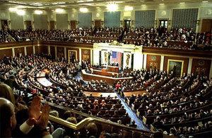


Special ratifying
____________
held in 3/4 of the states.

____________
____________
called by ____________
at the request of
____ of the _________.

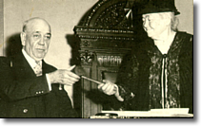

Used for all amendments except 21st.

Used only for Am. 21 (Repeal of Prohibition).
Method has never been used.

