Name:_______________________ Date:______________ Class:_______________

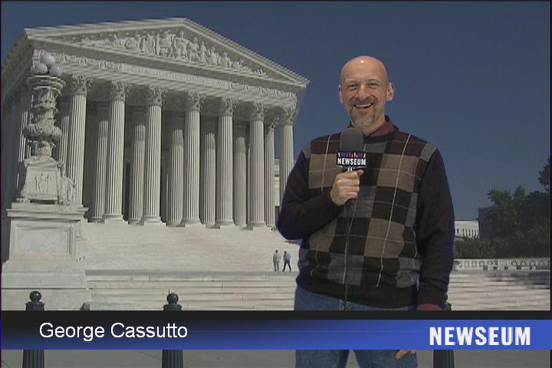
Investigating and Debating the Bill of Rights

A legal team will conduct an investigation into either side of the case. The team will divide into two smaller groups and find out what was argued in the case by one side. Each team member must take notes on the case and be ready to argue their side of the case before the class. As lawyers, you must be ready to respond to the case that the opposing side makes. Members of the class, acting as the Supreme Court, may ask you questions to find out more about the case or to see what you think the law or Constitution says about the situation in your case. Include previous cases that have guided the court before. The class will vote based on the information and persuasiveness of your presentation.

Case Name and Constitutional Question | Plaintiff  Argument | Defendant’s  Argument | Majority Decision of the Supreme Court
Engel v. Vitale (1962)
Is New York’s requirement of a state-composed prayer
unconstitutional?

Employment Division v. Smith (1990)
Can Oregon deny unemployment benefits to someone fired from a job for illegally smoking peyote during a religious ceremony?

Virginia v. Black (2003)
Is a ban on cross-burning an unconstitutional content-based restriction on free speech?

Name and facts of the case | Plaintiff  Argument | Defendant’s  Argument | Majority Decision of the Supreme Court
Village of Skokie vs. National Socialist Party (1978)
Can the National Socialist (Nazi) Party be prohibited from marching peacefully because of the content of their message?
Lewis v. United States (1980)
Can Congress prohibit convicted felons from owning firearms?

Mapp v. Ohio (1961)
Can evidence obtained by searches and seizures in violation of the Constitution be inadmissible in court?

Gregg v. Georgia (1976)
Does Georgia’s law imposing the death penalty violate the Constitution?
New Jersey v. T.L.O. (1985)
Does the Fourth Amendment ban on unreasonable searches apply to those conducted by public school officials as well as by law enforcement personnel?

