Political Party Identification Worksheet

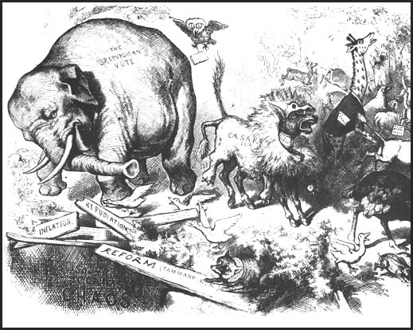
How well do you know that platforms of the two major American political parties? For each of the ideas listed below, indicate with D or an R which party hold the belief. We’ll exchange papers and see how you did.
Score: Number correct times 2 = _____ over 20.

___1) They favor tax cuts for all levels of society in the hope that increased consumer spending will lead to growth of America’s treasury.
___2) This party is willing to open up the Alaskan National Wildlife Research (ANWR) to oil exploration and drilling to reduce US dependence on foreign oil.

___3) They rejected the 1994 Health Care Plan, which would have placed a large federal agency in charge of insuring the 50 million Americans who lack any sort of health insurance.

___4) They believe in supporting the middle class and poor of American society by redistributing wealth through collecting taxes and creating social programs like Social Security, Medicare, and Medicaid.

___5) This party opposed the lifting of gun control laws such as the Assault Weapons ban, and they want to place a 30-day waiting period on the purchase of handguns.

___6) This party opposed large increases in defense spending because they say it hurts domestic spending on programs like public schools, child care, and assistance for America’s cities.

___7) This party supports the use of taxpayer funds in the form of vouchers to allow students who want to transfer to private schools in order to get a better education.

___8) This party is suspicious of businesses and feels that the government must make rules on issues like labor relations, pollution, and corporate greed.

___9) This party is more willing to use American forces overseas. In order to make the military stronger, the party supports increased spending on troops and weapons.

___10) This party wants to reduce America’s need for Middle East oil by investing in research for alternative energy sources such as wind, hydroelectric, and geothermal sources.

