The Electoral College
Label and include number of electoral votes for each state.

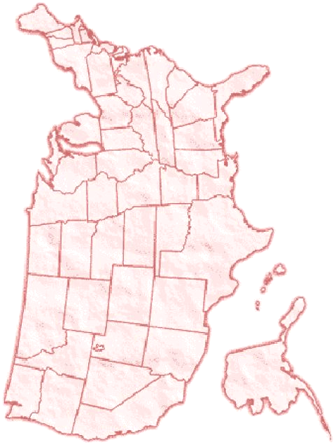
Source: Federal Register

http://www.archives.gov/federal_register/electoral_college/2004/allocation.html

Available: 2003

Total: 538

Majority Needed to Elect: 270

Alabama - | Montana -
Alaska - | Nebraska -
Arizona - | Nevada -
Arkansas - | New Hampshire -
California - | New Jersey -
Colorado - | New Mexico -
Connecticut - | New York -
Delaware - | North Carolina -
District of Columbia - | North Dakota -
Florida - | Ohio -
Georgia - | Oklahoma -
Hawaii - | Oregon -
Idaho - | Pennsylvania -
Illinois - | Rhode Island -
Indiana - | South Carolina -
Iowa - | South Dakota -
Kansas - | Tennessee -
Kentucky - | Texas -
Louisiana - | Utah -
Maine - | Vermont -
Maryland - | Virginia -
Massachusetts - | Washington -
Michigan - | West Virginia -
Minnesota - | Wisconsin -
Mississippi - | Wyoming -
Missouri -

Geography: The United States at a Glance
Using your textbook or encyclopedia as a resource, number the states on your Electoral College Map according their order as they entered the Union. Use your textbook, library, or Internet resources to complete the chart using the Electoral College Map.

State Name and Number |  | Date Entered Union | Electoral Votes | Capital

1

2

3

4

5

6

7

8

9

10

11

12

13

14

15

16

17

18

19

20

21

22

23

24

25

26

27

28

29

30

31

32

33

34

35

State Name and Number |  | Date Entered Union | Electoral Votes | Capital

36

37

38

39

40

41

42

43

44

45

46

47

48

49

50

For a state assigned to you, create a flash card that will help you remember this information. Draw a map of the state on one side and the key points on the other.

Map side Information Side
State:______________________
Number:______ Date_________
Electoral Votes:_____________
Capital:____________________
Other cool facts: ______________________________________________________
____________________________
State:______________________
Number:______ Date_________
Electoral Votes:_____________
Capital:____________________
Other cool facts:
1) __________________________
2) __________________________
3)___________________________

