11:1.4 – The Development of American Political Parties

What Is a Political Party?
- A ____________ is a group of citizens who want to influence government by getting the candidate of their choice elected.
- Parties nominate ____________ that’s share their views on major issues. Then they campaign to get them elected to public office.

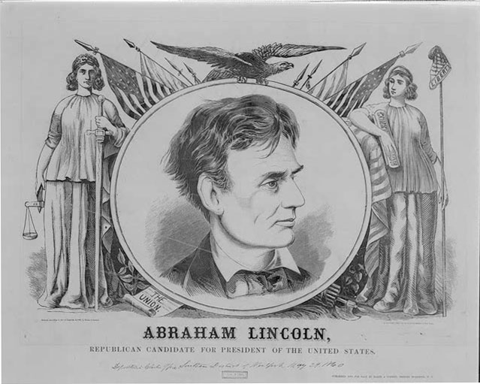
Parties in the United States
- Any American citizen may declare membership in a political party. Most members are of voting age.
- The United States has had a ____________ since Abraham Lincoln became the first Republican president in 1860.

Hamilton vs. Jefferson
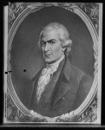
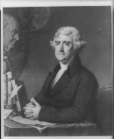
- Thomas Jefferson and Alexander Hamilton differed in their views on government and the Constitution.
- Jefferson’s followers called themselves the ________________________. They were suspicious of strong government, calling for power to reside with the states.
- Hamilton’s ____________ believed in powerful national government and a strong president.

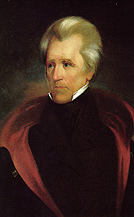
Jacksonian Democracy Reigns
- In 1828, Andrew Jackson was nominated as the leader of a new ____________ Party. This was based on the common people, the farmers and merchants of Jefferson’s party.
- Out of the split in the Dem-Reps rose the National Republicans (better known as The ____________).
- After 1830, the Whigs and Democrats remained the two major parties until the 1850s.

The Two Major Parties Emerge
- In 1854 Whigs, former Free Soil Party members, and ex-Democrats formed the ____________ Party to oppose the spread of slavery in U.S. territories.
- The Whigs faded from American politics leaving the Democrats and Republicans in a two-party system that has dominated American politics ever since.
Third Parties
- Any party other than the two major parties can be called a “____________.”
- A third party has never won a presidential election and rarely wins other major elections.
- When these smaller groups challenge the two major parties, they can change the outcome of elections.
- Their most important role is to ____________ on one or more issues.

Third Parties at the Turn of the Century
- In the late 1800s, the People’s Party, or “____________” became popular.
- They had the support of farmers and workers who called for better working conditions.
- They never succeeded in getting a national candidate into office; many of their ideas on workers’ rights became laws in the 20th Century.

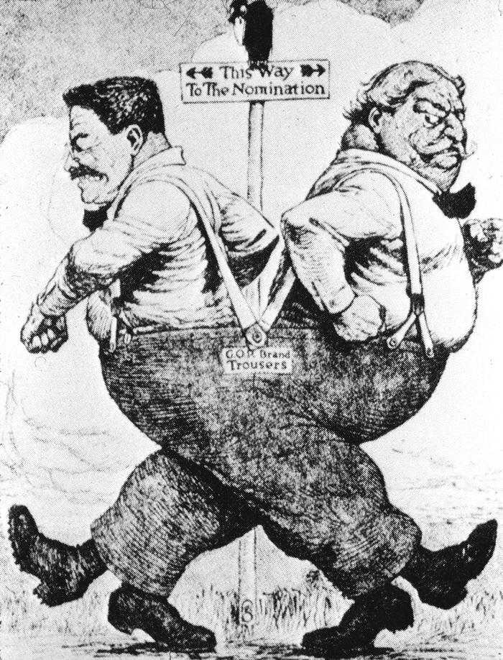
The Republicans Split
- Former Republican President Theodore Roosevelt left the Republican Party and was nominated by the ____________ Party.
- It was nicknamed the “Bull Moose Party” because TR said he was “fit as a bull moose.”
- TR split the 1912 Republican vote, allowing Democrat Woodrow Wilson to defeat President William H. Taft.

Ideological Third Parties
- An ideology is a body of ideas put forth by a person or group.
- Minor third parties are often formed to support a specific issue. These rise and fall over time.
- Ideological parties want to change society in major ways.
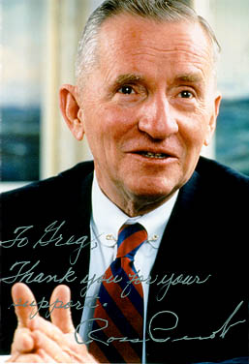
- The ____________ and ____________ Parties want to nationalize major industries. The Green Party calls for companies to respect the environment.

Cult of Personality
- Some third parties form from the efforts of famous people.
- If they cannot gain support from one of the major parties, they form their own.
- H. Ross Perot’s ___________ Party was a force in the 1992 and 1996 elections. This party also placed pro wrestler Jesse Ventura in the governor’s mansion in Minnesota.
- These parties usually fade after their candidate is defeated.

The Odds Are Against Them
- It is difficult for third parties candidates to raising enough money to compete with the major parties.
- Only one candidate can win in a given district. Usually the winner is either Democratic or Republican.
- Third-party candidates must show they have support by getting ______________________ to even be placed on the ballot for national office.
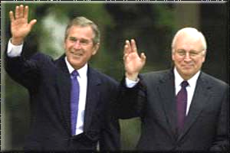
American Politics Today
- Democrats usually feel that the federal government has a responsibility to help the poor through government ____________.
- Democrats are generally seen as ____________.
- Republicans hold the view that leaving the economy alone will allow for growth, giving people greater ability to help themselves. They believe in less regulation.
- Republicans are viewed as being ____________.

Parties move toward the center
- A ____________is a statement that puts forth the party's positions on issues. Each individual issue is called a ____________.
- Both parties want votes. As a result, they tend to avoid extremes.
- The American people generally agree about many issues. This forces the two parties toward the center of the political spectrum.

Political Party Systems in other Countries:

- Most democracies have ____________ systems.

- One party rarely wins enough support to control the government, so several parties must work together. This is called a ____________.

- If a small party pulls its support, the government can collapse and new elections must be held. This process occurs in nations with a ____________ system of government.

- The United States has a _________________ system and a Congress rather than a prime minister and a _________________.

Following the (One) Party Line:

- A one-party system cannot exist in a ________________. There is no choice of candidates in the elections.
- ________________ parties are usually banned.

- _______________ China, Cuba, and North Korea operate under one-party systems.
- One-party systems also exist in some non-Communist nations. Muslim leaders control ____________ Islamic Republican Party.
- This type of religion-based government is called a _________________.

