Learning From Pictures: Forms of Government
- Give cooperative groups of three or four an image to analyze along with a corresponding vocabulary term. Students should present to the class their opinions on the following questions regarding their image:
- What is happening in the image?
- How does the vocabulary term relate to the image? How does it relate to the forms of government that exist or have existed throughout history?
- List any people or historical figures seen in the image. Describe what they are doing in the image.
- Students should write out a one-two sentence description for each main idea.
- Instruct students to present their reactions to the class. Students should share the address of their image so all students can view the image as they discuss and present their findings.

Images to Choose From

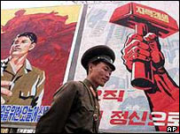 | 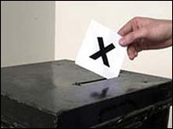 | 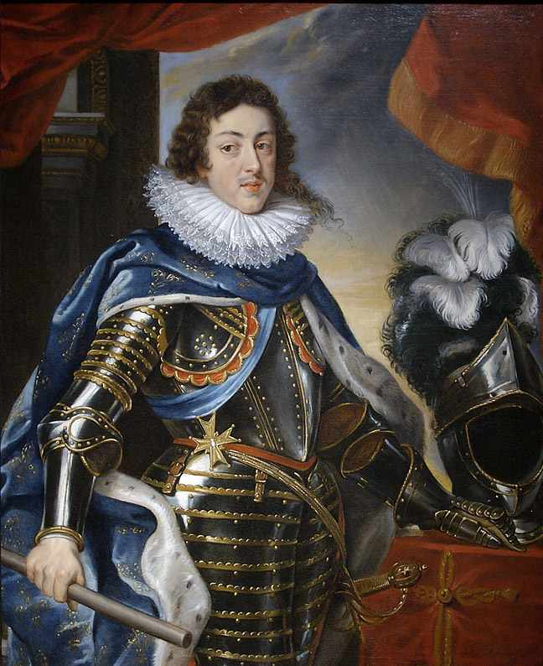
Totalitarianism | Democracy | Absolute Monarchy
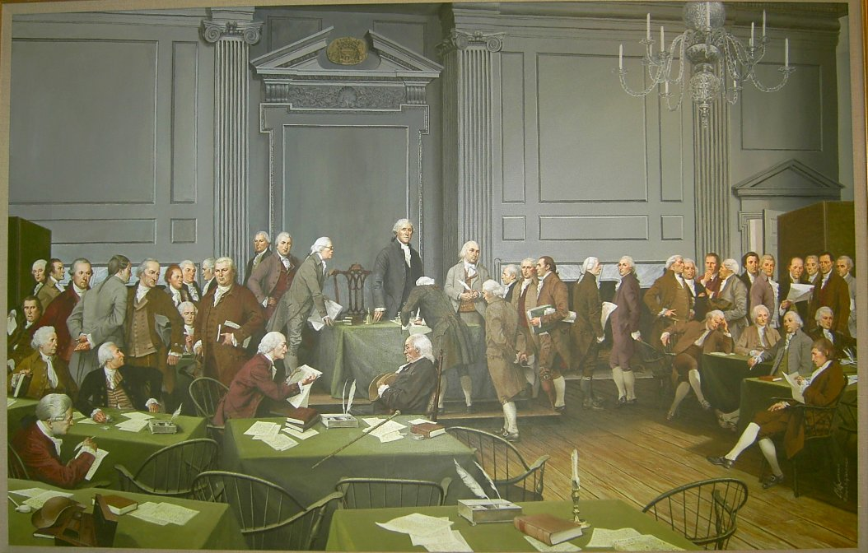 | 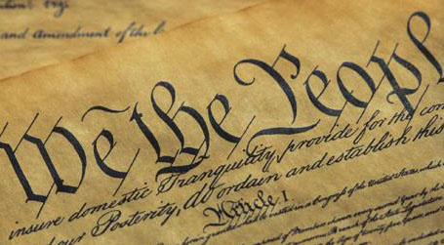 | 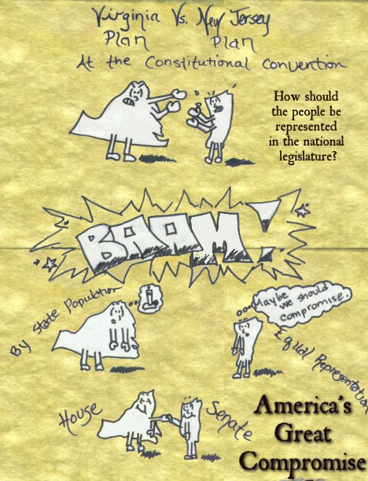
Constitutional Convention | Government | Great Compromise

