11.2.1 – Assignment: The Path to the White House
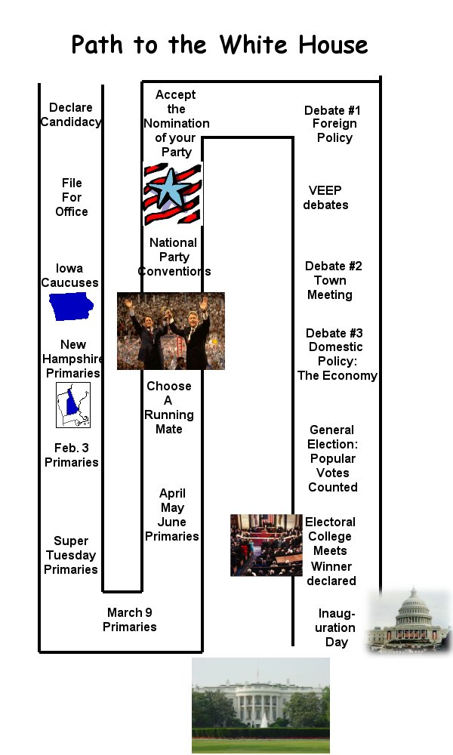
Using the graphic entitled Path to the White House, create a story that tells how a fictitious president, or a real one from history, went through the electoral process. You must mention each of the steps in the process and include five vocabulary terms from your textbook or vocabulary worksheet that deal with the electoral process. Your usage of each term and step must be correct to receive credit.
Caucuses: These are meetings of party members who choose a nominee.
New Hamp-shire’s voters often lead the way for later state primaries.
Super Tuesday:
Six southern states, (FL, LA, MS, OK, TN, & TX), hold primaries in March.

Con-vent-ions are held over 4 days.
Accep-
tance speech given on Day 3.
Held on the first Tues. after the first Mon. in Nov.
First meeting is in Dec. in state capitals. Then in Jan. 6 in the House.
Jan. 20.
(20th Am)
Each party now knows who its nominee is.
Conventions confirm voters’ choices for nominee in the primaries

