10:5 – Vocabulary Matching: Judicial Branch
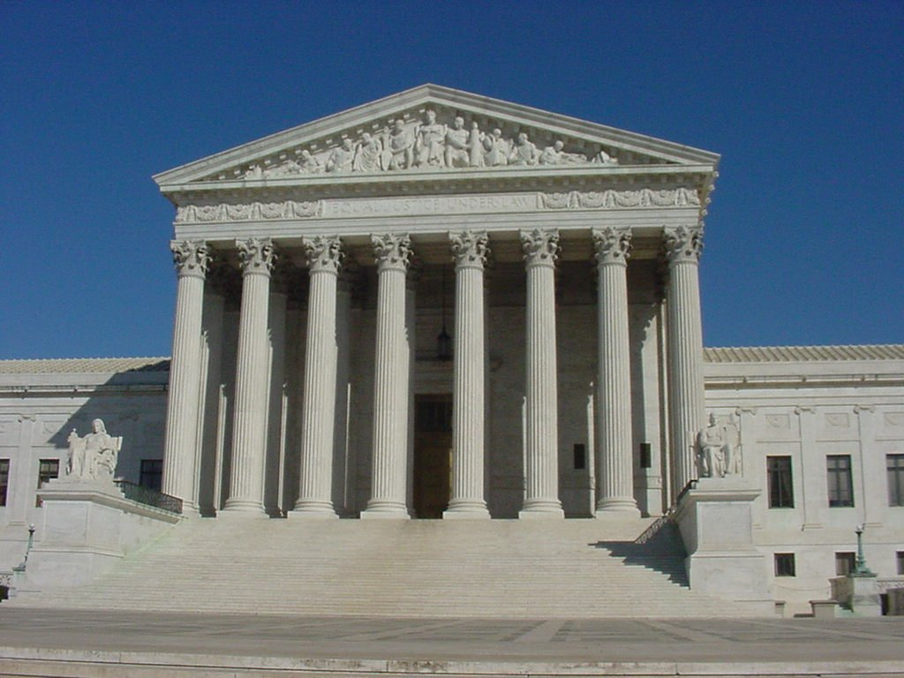
Match the terms with the definition

Types of Law
A. Constitutional Law
B. Common Law
C. Administrative Law
D. Statutory Law

____1. This type of law is made by lawmaking bodies such as Congress.
____2. These laws are based on rules that have been accepted by Americans and common sense. It is often based on judges’ decisions.
____3. Laws that are set up by government agencies fall into this category.
____4. Any law having to do with our written plan of government falls into this category. It is the highest law in the land and no law can overrule it.

Rights of the Accused
A. The Supreme Court | B. Appeal
C. Trial by jury | D. Grand Jury
E. Free on Bail | F. Representation by a lawyer

____5. This right makes sure that a person who knows the law will help protect the rights of an accused person.
____6. This right allows an accused person to have freedom until the trial if a certain amount of money has been paid to the court. Sometimes, if the crime is very serious, this right is taken away.
____7. This group must formally accuse a person of a crime before a trial is held. The accusation, called an indictment, must be based on evidence.
____8. The Sixth Amendment guarantees this right. It ensures that a petit jury decides if a crime has been committed based on evidence.
____9. Citizens have the right to ask a higher court to hear their case if they disagree with a lower court’s decision. This right is called the right to _____.
____10. This court does not hear cases of guilt or innocence. It only determines if the rights of Americans have been violated or if the constitution is in question.

Use the answers below to fill in the blanks.
A. Original | B. Appellate | C. U.S. District Court
D. Subpoena | E. Supreme Court | F. Court martial

____11. The first court to have the right to hear a case has ___________________ jurisdiction.
____12. Persons accused of breaking a military law are tried at a _________ _______, which is conducted by military officers.
____13. An official court order for a person to appear in court in order to testify is called a ________________________.
____14. Courts that have the power to review cases coming up from lower trial courts are said to have ___________________ jurisdiction over those cases.
____15. The lowest court in the Federal court system is the _______________court.
____16. It hears cases involving situations where a person’s constitutional rights have been violated.

Choices
A. Unconstitutional | B. Legal rights
C. Brief | D. Opinion
E. Concurring Opinion | F. Dissenting Opinion
G. Segregation | H. "Equal protection Under Law"
I. Judicial Review | J. John Marshall

____17. In the case of Marbury vs. Madison, this (third) chief justice of the United States put forth the idea of ______ ______. It is the power of the Supreme Court to determine whether a law passed by Congress or presidential action is in accord with the Constitution.
____18. If the Supreme Court decides that a law conflicts with the Constitution, then the law has been declared _______________________________, and it is no longer in effect.
____19. If the Supreme Court decides to hear a case, lawyers for both sides submit a written statement explaining the main points of their argument. What is this statement called?
____20. The viewpoint held by the majority of justices in the case is called the majority _____________________. The Chief Justice assigns writing the viewpoint of the majority.
____21. If a justice agrees with the majority but for different reasons, the justice may write the _______ _________.
____22. Justices who disagree with the decision of the court explain their reasoning in the ____________ ____________.
____23. In Plessy vs. Ferguson (1896) the Supreme Court decided that this practice was legal in the United States as long as public facilities for blacks and whites were equal. This idea came to be known as "separate but equal."
____24. In Brown vs. Board of Education (1954), the idea of "separate but equal" was declared unconstitutional because it violated which idea contained in the 14th Amendment?
____25. The case of Miranda vs. Arizona stated that police must inform suspects of this idea before questioning them.

Extra credit: State (in a full sentence) one type of case that is handled by the Supreme Court.
____________________________________________________________________________
____________________________________________________________________________
____________________________________________________________________________

