Name_____________________________________ Class Period__________________

Remembering September 11, 2001
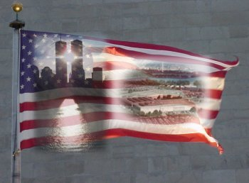
September 11, 2001 was tragic yet pivotal day in our nation’s history. The day is important not only because we pause to remember those who lost their lives, but also to reflect on what we have learned as a nation. In the space below, create a list of ideas that describe how the United States has become a better society since the time of the attacks.
________________________________________________________________________________________________________________________________________________________________________________________________________________________________________________________________________________________________________________________________________________________________________

In the space provided, create an image, poem, or essay with a title that uses the ideas you listed above to show what Americans have learned about themselves and the world as a result of what happened on September 11, 2001. Remember to use symbols, both visually or with language, that describes the lessons we have gained as those events move from current events into history.

